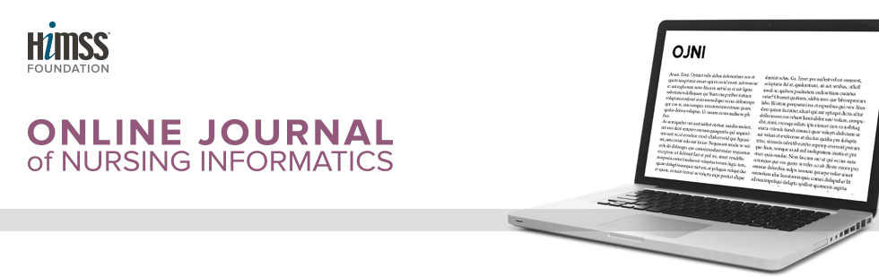
OJNI Submissions: Our Peer Review Process
Each manuscript is reviewed by the Editor-in-Chief and sent to the Senior Managing Editor who assigns the two peer reviewers.

The requested time period for review is two weeks. Please remember that our reviewers are volunteers so the process may take longer than the requested two weeks for review.

Reviewers’ comments, suggestions, and recommendations on publication are summarized by the Senior Managing Editor and shared with the authors.

One of four possible decisions is made: 1.) accept for publication (pending copyediting), 2.) accept provisionally pending minor revision by authors, 3.) revise by authors and 4.) re-review by peers, or reject.

If a manuscript is accepted for publication, authors will be asked to respond to the following:
- Include a brief bio (one paragraph) for each author
- List your names and credentials as you would like them to appear in OJNI
- Exact title for your article
- Confirm the following:
  - I, (add your full name), as primary author on behalf of myself and any other authors associated with this work, understand that submitting the above information via email constitutes agreement with the following statements:
  - I give OJNI permission to publish the article listed above.
  - I have only submitted this article to OJNI and it has not been published anywhere else or in any other format.
  - I certify that this is my/our original work and that all references to the work of others are properly represented and cited.

The manuscript is sent to the copyeditor for editing. Issues discovered at this stage may necessitate action by the authors or in the case of plagiarism or subpar scholarship; manuscripts may still be rejected at this stage. The copyeditor returns the manuscript to the Senior Managing Editor who will add the journal citation and the author bios. The manuscript is then returned to the lead author for a final review prior to publication. The Senior Managing Editor completes the edition line-up form and submits the manuscripts to the Editor-in-Chief and the Chief Senior Editor (Web) by the 15th of the month prior to publication (January 15, May 15 and September 15).

